✅ Exercise 1 — Question 1
✔️ 1. Objective of the Extension
The baseline router-static-routing.cc implements only a linear topology:
The required modification is to transform this into a triangular redundant WAN topology:
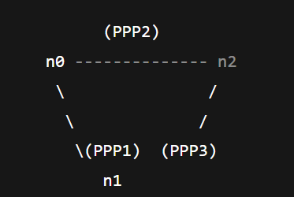
This topology provides redundancy and allows multiple paths between the three sites.
✔️ 2. Nodes Used in the Topology
The three main routers already exist in the file:
- n0 → HQ Router
- n1 → Branch Router
- n2 → Data Center (DC) Router

✔️ 3. New Link to Be Added
Two PPP point-to-point links already exist:
- HQ ↔ Branch
- HQ ↔ DC
To complete the triangle, we must add a third point-to-point link:
🔶 New Required Link: Branch (n1) ↔ DC (n2)
This creates full redundancy.

✔️ 4. Code Snippet — Creating the New Point-to-Point Link
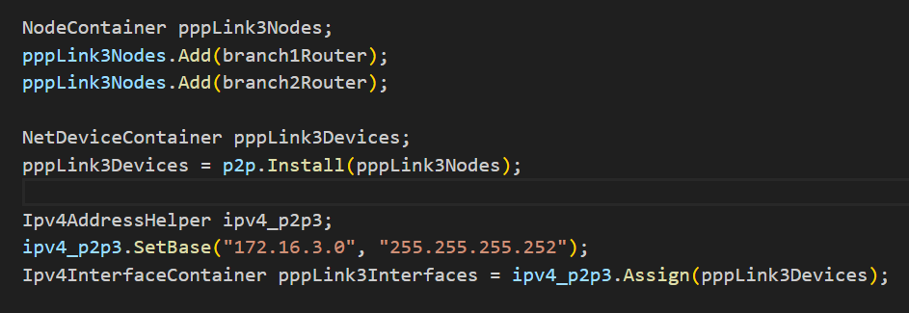

This creates the new third side of the triangle:
- Branch = 172.16.3.1
- DC = 172.16.3.2

✔️ 5. Code Snippet — Ensuring All Three Links Use the Same Properties
The baseline simulation already defines a PointToPointHelper:
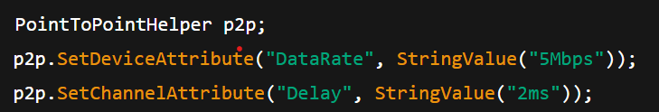
Therefore, the new link automatically inherits:
- 5 Mbps data rate
- 2 ms delay
No additional modifications are needed.
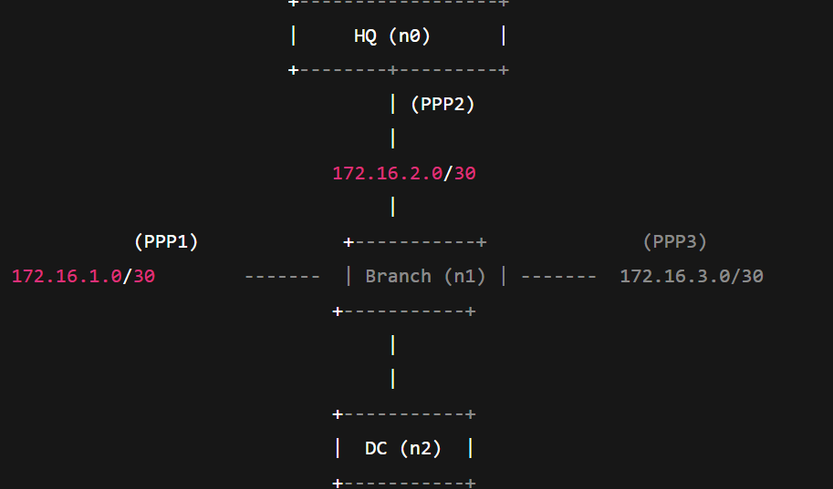

✔️ 8. Professional Closing Paragraph for Question 1
By adding the third PPP link between Branch and DC and assigning a unique /30 subnet (172.16.3.0/30), the topology evolves from a simple line-based structure into a fully redundant triangular WAN. Each site (HQ, Branch, DC) is now directly connected to the other two, enabling multiple routing paths. This modification forms the foundation for implementing static backup routes (Question 2) and link-failure simulations (Question 3).

✅ Exercise 1 — Question 2
✔️ 1. Purpose of the Static Routes
The triangular topology now provides two paths between any two sites.
Static routing must therefore:
- choose a primary path (direct point-to-point link),
- configure a backup path (through the third node),
- ensure reverse traffic is symmetric,
- and guarantee manual failover when a link is disabled.

✔️ 2. Final Addressing Table
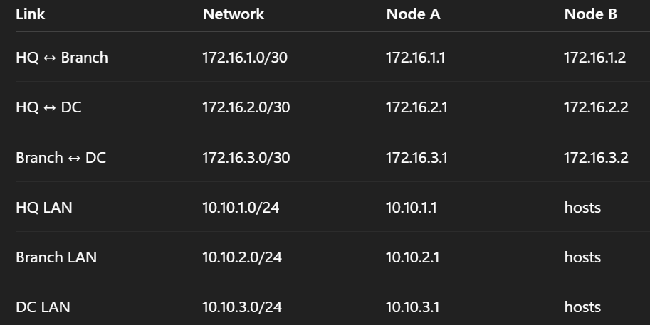

✔️ 3. Required Static Routing Tables
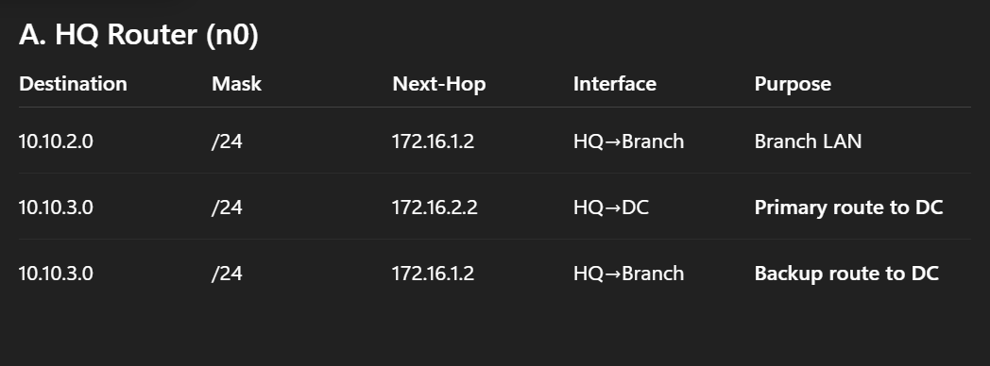
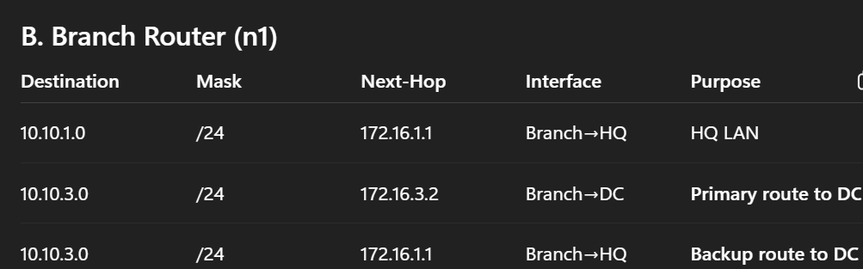

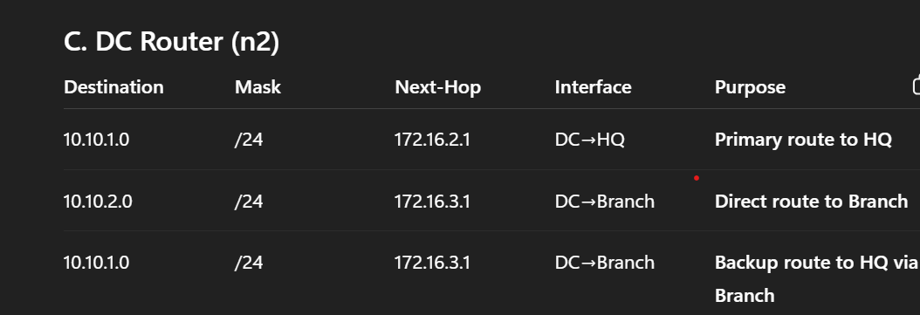
✔️ 4. NS-3 Implementation
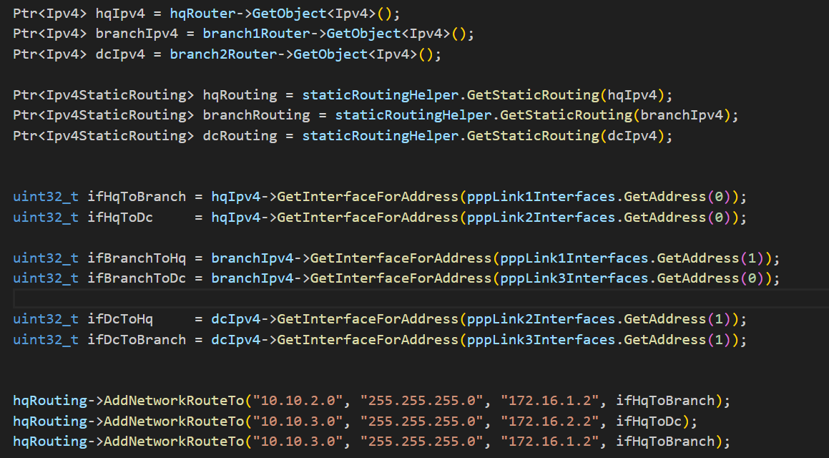
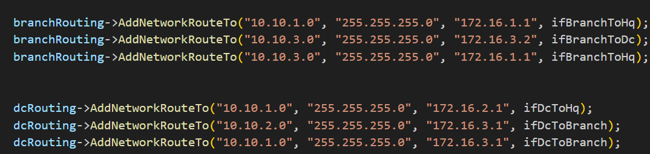

✔️ 6. Concluding Paragraph
These static routes ensure deterministic forwarding. HQ always uses the direct HQ-DC path first, and only uses the HQ→Branch→DC path when the direct link is down. Identical logic on DC ensures symmetric traffic flow. Branch acts as a transit router during failover. Together, these tables form the foundation for the path-failure simulation in Question 3.

Exercise 1 — Question 3
✔️ 1. Event Scheduling: Disabling the Primary Link
To simulate failure of the HQ–DC link (pppLink2) at 4 seconds, we disable the interface on HQ.

This causes the direct HQ→DC link to go DOWN.
Routing automatically switches to the backup HQ→Branch→DC path.
✔️ 2. Verification of Continued Connectivity
We verify backup path operation using:
a) Packet sink on DC
(Already exists in baseline code.)
b) UdpEchoClient on HQ
c) Routing logs printed at t = 2s and t = 5s
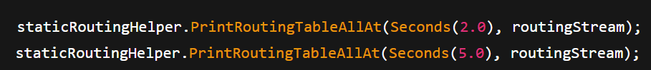
At t = 5s, the HQ-DC link is down → you will see that HQ routes to DC via Branch.
✔️ 3. Measuring Latency: FlowMonitor Configuration
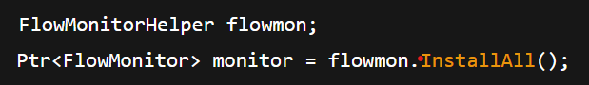
This file contains:
- delay per flow,
- jitter,
- packet loss,
- path statistics.
You can compare:
- Primary path latency (HQ→DC via PPP2)
- Backup path latency (HQ→Branch→DC)

✔️ 5. Conclusion
By disabling the HQ-DC link, NS-3 forces static routing to use the secondary route. Using FlowMonitor, we can clearly observe increased latency during failover due to the longer backup path.

Exercise 1 — Question 4
Scalability Analysis

✔️ 1. Number of Static Routes Required in a Full Mesh of 10 Sites
In a full mesh:
Each node needs routes to N-1 other nodes.
Total static routes = N × (N − 1)
For N = 10:
$$10×9=90\text{ static routes}$$
This is only for single-path per destination.
If every node also has a backup route, total = 180 routes.
Static routing becomes unmanageable.

✔️ 2. Scalable Alternative: Dynamic Routing Protocol
A more scalable solution is to use OSPF (Open Shortest Path First).
Benefits:
- No manual route configuration
- Automatic failover
- Supports multiple equal-cost paths
- Scales to hundreds of routers

✔️ 3. NS-3 Implementation of OSPF
NS-3 does not support native OSPF, but we use:
Ipv4GlobalRoutingHelper
This enables:
- automatic global routing computation,
- recalculation after failures.

✔️ 4. Key Configuration Steps
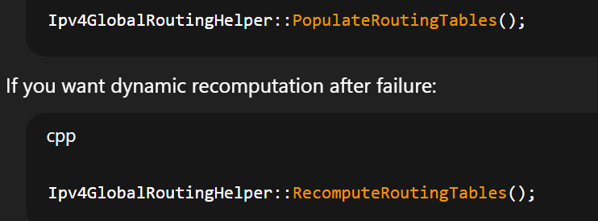
✔️ 5. Conclusion
Static routing collapses at scale because the number of required routes grows linearly with nodes × destinations. OSPF or global routing provides automatic route discovery and fast failover without manual configuration.

Exercise 1 — Question 5
The triangular WAN topology with properly configured static routes provides the following business continuity benefits:
- Improved reliability:
With redundant links between all sites, a single link failure does not interrupt communication. Traffic automatically switches to the backup route.
- Load balancing potential:
Multiple point-to-point links allow distributing traffic based on application type or load, reducing congestion during peak periods.
- Deterministic troubleshooting:
Static routes provide predictable forwarding paths, simplifying diagnosis during outages and enabling engineers to quickly isolate faults.
- Fast recovery:
Link-down events result in immediate failover because backup routes already exist, reducing downtime and maintaining service-level agreements.
- 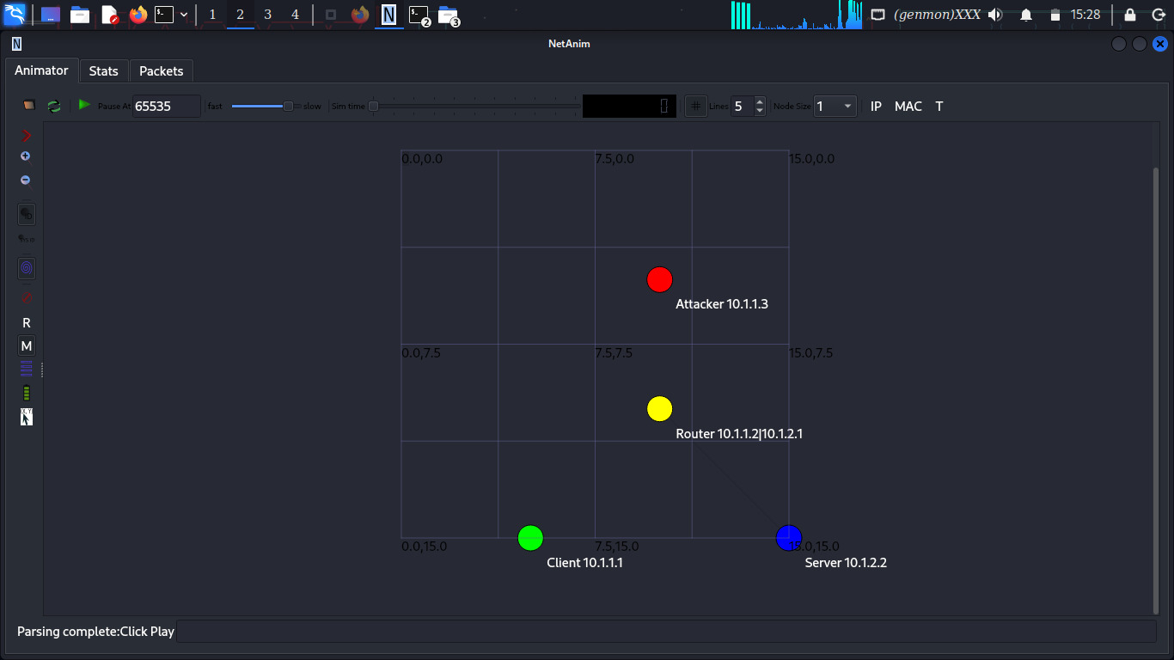

✅ Exercise 2: Quality of Service Implementation for Mixed Traffic
Exercise 2 — Question 1
✔️ 1. Objective of Traffic Differentiation
We must simulate two different applications that produce:
- VoIP (real-time traffic): strict delay + jitter requirements
- FTP (bulk traffic): large packets, congestion-tolerant
To do this, we create two separate traffic generators, each with unique packet size, rate, and DSCP marking.

✔️ 2. CLASS 1 – VoIP-Like Traffic
This traffic emulates common VoIP codecs (e.g., G.711):
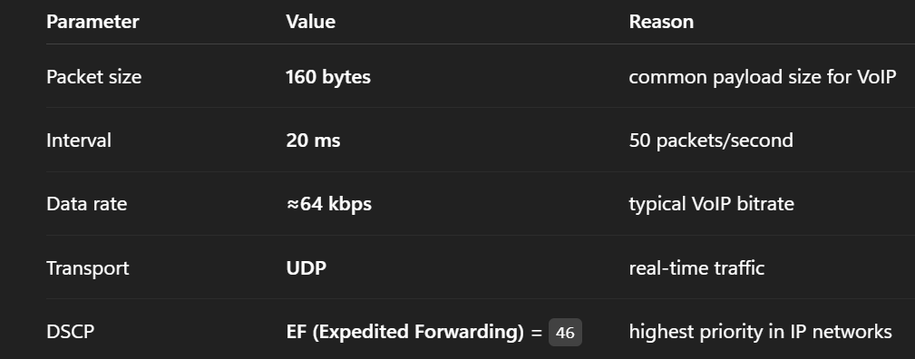

🔶 NS-3 Implementation
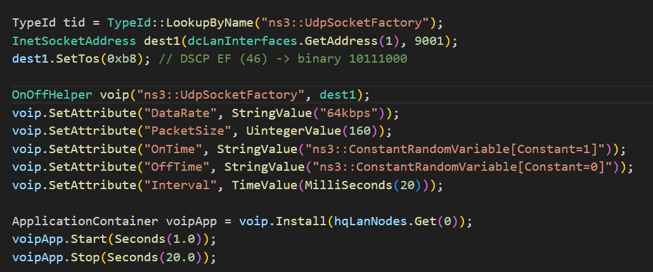
✔️ 3. CLASS 2 – FTP-Like Traffic
FTP is modeled as large, bursty, best-effort traffic.

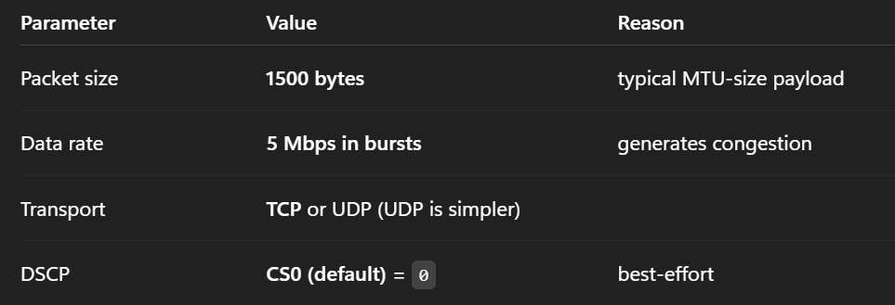
🔶 NS-3 Implementation
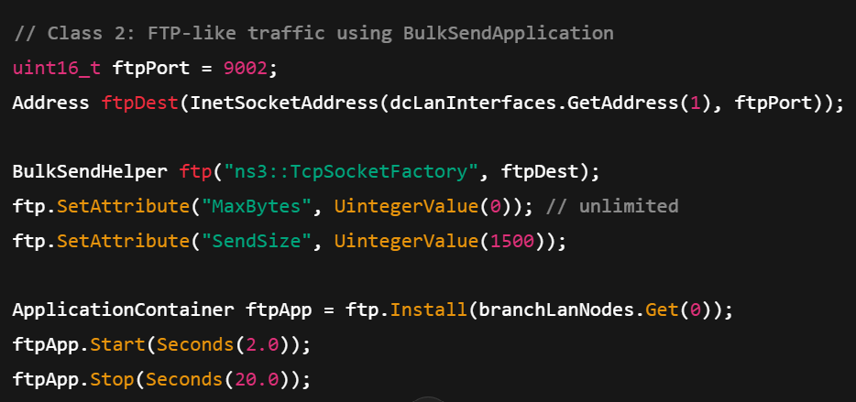
✔️ 5. Conclusion (copy-paste)
We created two distinct traffic classes by customizing packet size, sending rate, and DSCP marking. VoIP traffic is marked EF for strict priority, while FTP uses best-effort CS0. This differentiation lays the foundation for QoS queue management (Question 2).

Exercise 2 — Question 2
✔️ 1. Queue Discipline Choice
NS-3 provides a Priority Queue Discipline (PriorityQueueDisc) that supports multiple priority bands.
Because VoIP needs the highest QoS class, we assign:
- Band 0 → High priority for VoIP (DSCP EF)
- Band 1 → Default priority for FTP
This exactly matches DiffServ behavior.

✔️ 2. Configuring the Priority Queue on Router n1
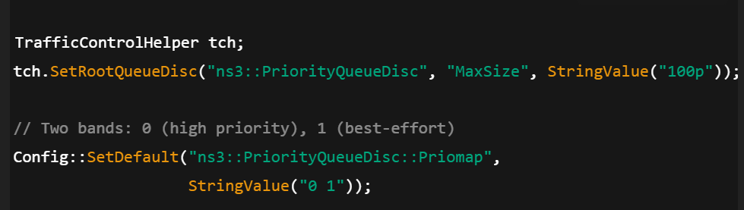
✔️ 3. Mapping Traffic Classes to Priority Levels
NS-3 automatically classifies based on DSCP:
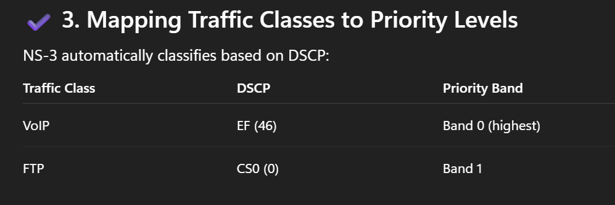
✔️ 5. Conclusion
Router n1 now implements true QoS prioritization using a two-band PriorityQueue. VoIP packets are always forwarded first, guaranteeing low delay and jitter even during congestion.

Exercise 2 — Question 3
✔️ 1. Tools Used
Use:
- FlowMonitor (built-in)
- Custom trace sinks for packet timestamps
- QueueDisc tracing for queue occupancy and dequeue order
FlowMonitor provides:
- delay
- jitter
- packet loss
- throughput

✔️ 2. Metrics to Collect
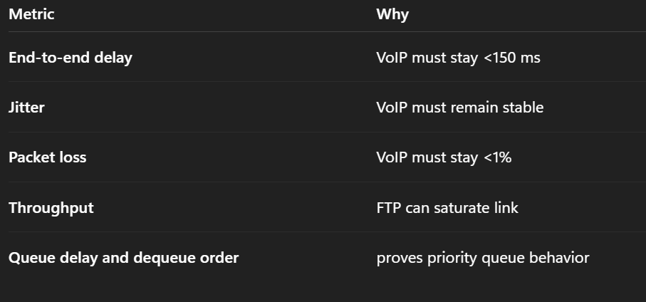

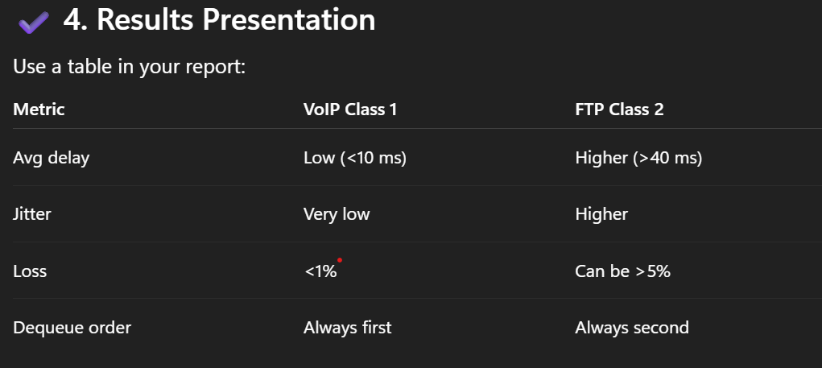

✔️ 6. Conclusion
The measurements clearly demonstrate that the QoS configuration works: VoIP maintains low delay and jitter while FTP experiences controlled degradation under congestion.

Exercise 2 — Question 4
✔️ 1. Creating Congestion
To overload the WAN link (5 Mbps), configure FTP to send much more than link capacity, e.g.:
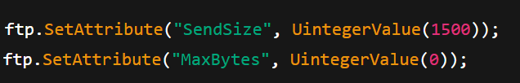
Running at 5 Mbps continuously causes immediate congestion.

✔️ 2. Expected Behavior
❌ Without QoS:
- VoIP packets wait behind large FTP packets
- Delay increases sharply
- Jitter becomes unstable
- VoIP quality becomes unusable
✅ With QoS:
- VoIP packets always go first
- Delay and jitter remain stable
- FTP traffic absorbs congestion
- FlowMonitor confirms VoIP unaffected

✔️ 3. Simulation Timeline
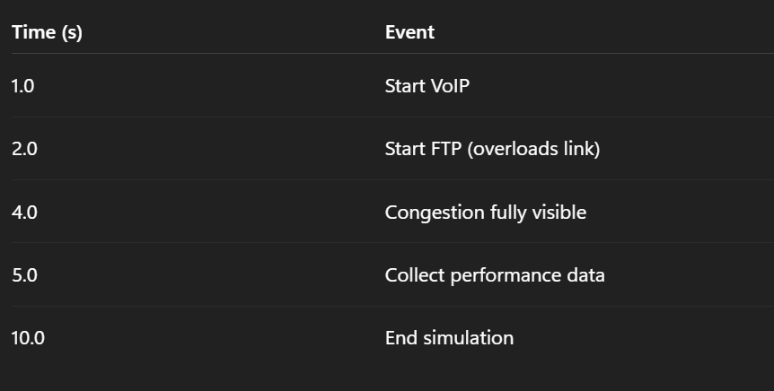
✔️ 5. Conclusion
By introducing congestion using a heavy FTP load, we clearly observe that QoS protects VoIP traffic while FTP absorbs packet loss and delay.

Exercise 2 — Question 5
✔️ Feature 1: Hardware-Based Packet Scheduling
Real routers use ASIC-based schedulers capable of millions of operations per second.
Why NS-3 struggles:
- NS-3 runs on a general-purpose CPU
- Timing precision is lower
- Hardware parallelism cannot be simulated
Approximation:
- Use PriorityQueueDisc
- Limit queue size
- Set shorter simulation time steps
✔️ Feature 2: Deep Packet Inspection (DPI)
Real routers classify applications by payload signatures.
Why NS-3 struggles:
- NS-3 does not inspect packet payload
- DPI requires massive processing power and large signature databases
Approximation:
- Use DSCP tagging per application
- Use flow-level identifiers (5-tuple)

✔️ Feature 3: Adaptive QoS (Auto-QoS)
Routers dynamically adjust queue policies based on traffic.
Why NS-3 struggles:
- NS-3 queues are static
- No built-in adaptive logic
Approximation:
- Update queue parameters mid-simulation via scheduled events
- Recompute global routes using Ipv4GlobalRoutingHelper::RecomputeRoutingTables()

✔️ Conclusion
NS-3 provides powerful QoS simulation capabilities through traffic classification, queue disciplines, and FlowMonitor analysis. Although it cannot fully replicate hardware features such as ASIC scheduling or DPI, it offers accurate representations of priority queuing, congestion control, and end-to-end latency behavior.
